**Monday, 7 October 2019**

Controlling Stepper Motor NEMA 17 using A4988

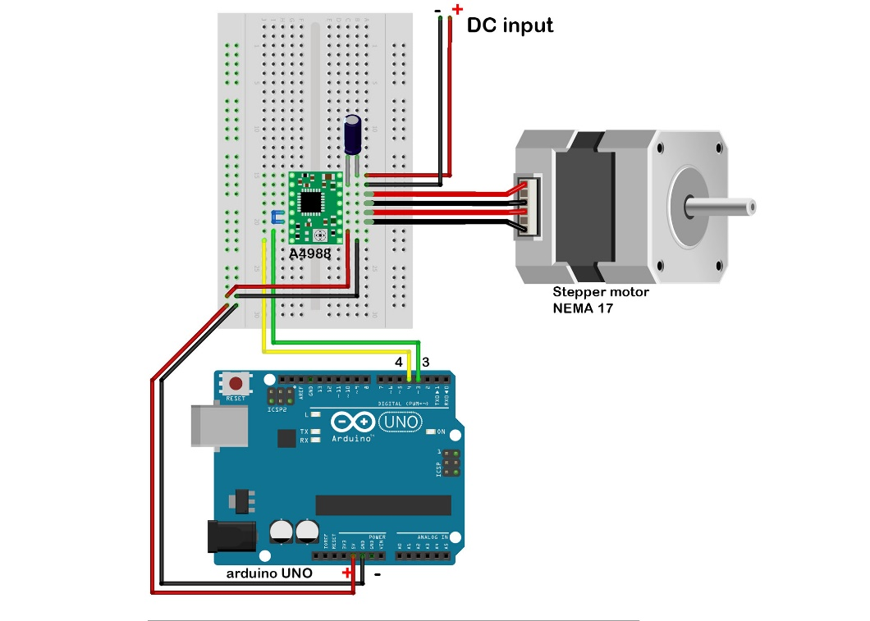

// Stepper motor run code with a4988 driver

// by Superb

const int stepPin = 6; // define pin for step

const int dirPin = 9; // define pin for direction

void setup() {

pinMode(stepPin,OUTPUT);

pinMode(dirPin,OUTPUT);

}

void loop() {

digitalWrite(dirPin, LOW); // set direction, HIGH for clockwise, LOW for anticlockwise

for(int x = 0; x<200; x++) { // loop for 200 steps

digitalWrite(stepPin,HIGH);

// delay(500);

delayMicroseconds(1000);

digitalWrite(stepPin,LOW);

delayMicroseconds(1000);

}

// delay for 1 second

delay(5000);

}

Controlling Stepper Motor NEMA 17 using A4988 (Potentiometer Speed Control)

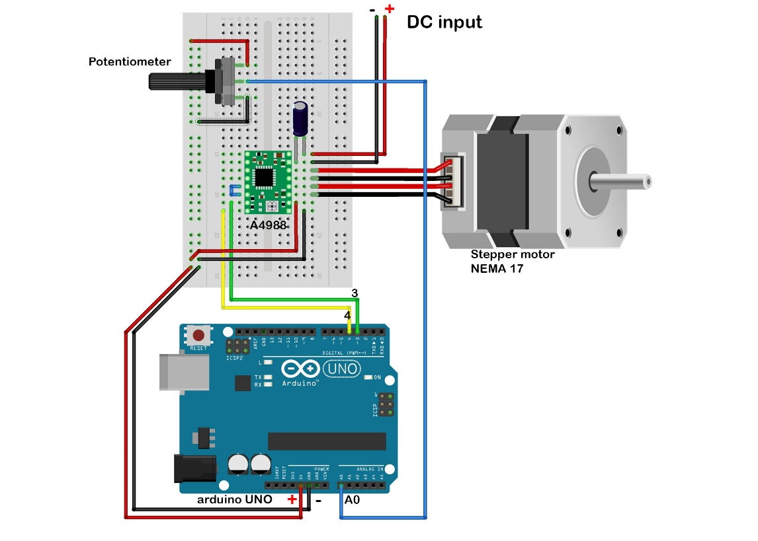

// Stepper motor run code with a4988 driver

// by Superb

const int stepPin = 6;

const int dirPin = 9;

int customDelay,customDelayMapped; // Defines variables

void setup() {

// Sets the two pins as Outputs

pinMode(stepPin,OUTPUT);

pinMode(dirPin,OUTPUT);

digitalWrite(dirPin,HIGH); //change the rotation direction HIGH for clockwise and LOW for anticlockwise

}

void loop() {

customDelayMapped = speedUp(); // Gets custom delay values from the custom speedUp function

// Makes pules with custom delay, depending on the Potentiometer, from which the speed of the motor depends

digitalWrite(stepPin, HIGH);

delayMicroseconds(customDelayMapped);

digitalWrite(stepPin, LOW);

delayMicroseconds(customDelayMapped);

}

// Function for reading the Potentiometer

int speedUp() {

int customDelay = analogRead(A0); // Reads the potentiometer

int newCustom = map(customDelay, 0, 1023, 300,4000); // Convrests the read values of the potentiometer from 0 to 1023 into desireded delay values (300 to 4000)

return newCustom;

}

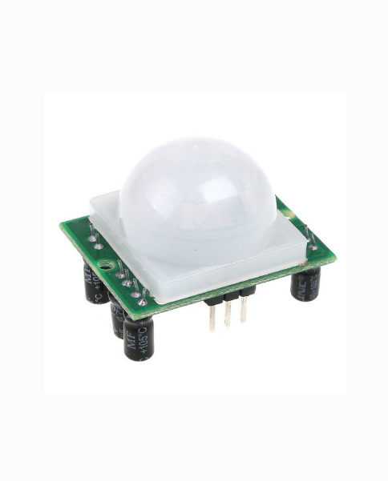07-10-19 11.55.54 PM

**PIR Motion Sensor using Arduino**

Passive Infra-Red

* 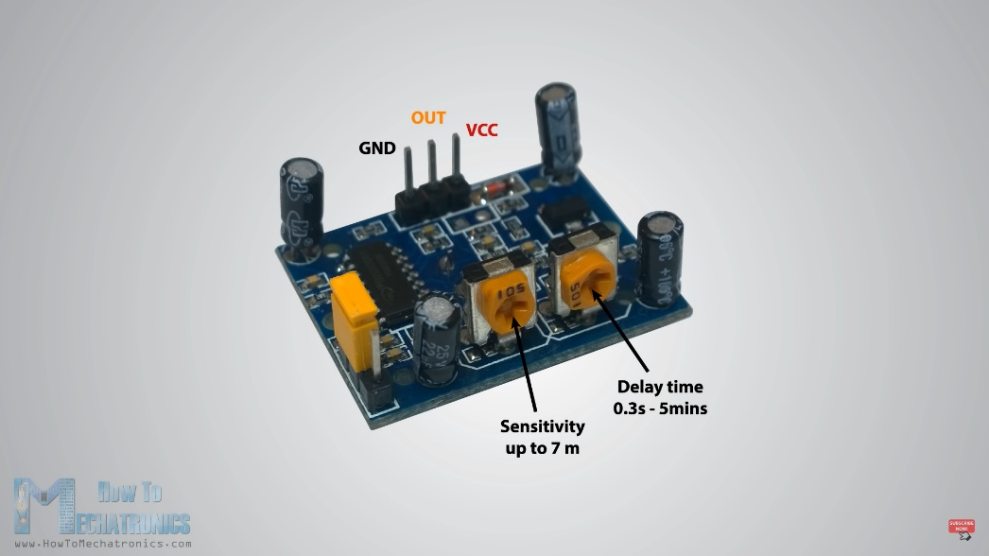Can detect any moment around it
* Frensel Lense
* 3 Pins
  + VCC
  + GND
  + Signal (Central)
* Trigger Mode
  + Repeatable
  + Non-Repeatable
* Corner Side is Non-Repeatable Mode (once motion is sensed in sensitive area and Delay Time is Over, O/P Signal is LOW
* Other Side is Repeatable Mode (Although delay time is over, it will keep on checking sensitive area if motion is there, O/p Signal remain high

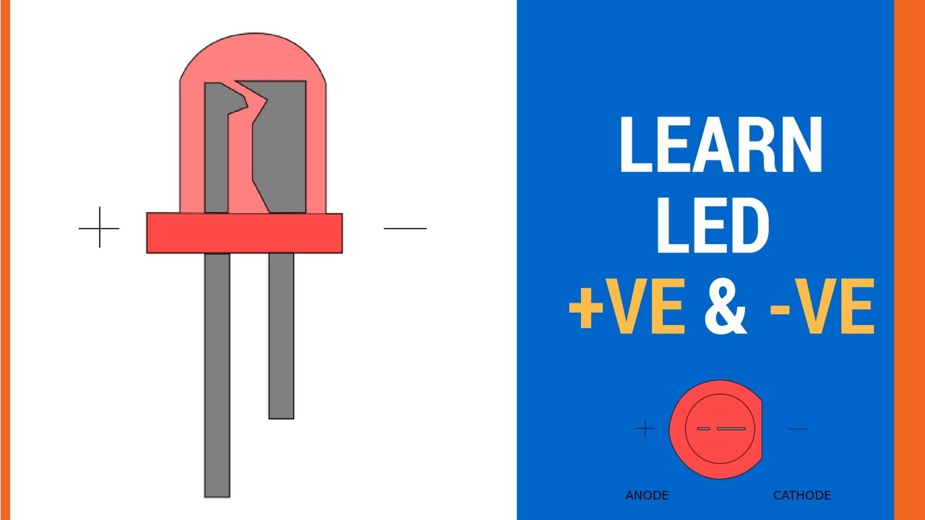

/* Arduini PIR Motion Sensor Tutorial

*

* by Dejan Nedelkovski, www.HowToMechatronics.com

*

*/

int pirSensor = 8;

int led = 5;

void setup() {

pinMode(pirSensor, INPUT);

pinMode(led, OUTPUT);

Serial.begin(9600);

Serial.println("Program is started!");

}

void loop() {

int sensorValue = digitalRead(pirSensor);

if (sensorValue == 1) {

Serial.print(sensorValue);

digitalWrite(led,HIGH);

}

else{

Serial.println("No output is detected");

digitalWrite(led,LOW);}

}

08-10-19 1.05.18 AM

**2 Relay Module Control with Arduino**